CLASS TEST 1
REGULAR EXPRESSIONS AND VALIDATION IN JAVASCRIPT
Name: N. Sai Preethika Register Number: 192372344

1. Student Registration Validation
The program validates full name, email, a 10-digit mobile number, date of birth in DD-MM-YYYY format, and a password of at least eight characters containing uppercase, lowercase, digit, and special character.
JavaScript Program
function validateRegistration(name, email, mobile, dob, password) {
const errors = [];

if (!name.trim() || !/^[A-Za-z]+(?:[ '-][A-Za-z]+)*$/.test(name.trim())) {
errors.push("Enter a valid full name.");
}
if (!/^[^\s@]+@[^\s@]+\.[A-Za-z]{2,}$/.test(email)) {
errors.push("Enter a valid email address.");
}
if (!/^\d{10}$/.test(mobile)) {
errors.push("Mobile number must contain exactly 10 digits.");
}

const dateMatch = dob.match(/^(\d{2})-(\d{2})-(\d{4})$/);
if (!dateMatch) {
errors.push("Date of birth must be in DD-MM-YYYY format.");
} else {
const day = Number(dateMatch[1]);
const month = Number(dateMatch[2]);
const year = Number(dateMatch[3]);
const date = new Date(year, month - 1, day);
if (date.getFullYear() !== year || date.getMonth() !== month - 1 ||
date.getDate() !== day) {
errors.push("Enter a real calendar date.");
}
}

if (password.length < 8 || !/[A-Z]/.test(password) ||
!/[a-z]/.test(password) || !/\d/.test(password) ||
!/[^A-Za-z0-9]/.test(password)) {
errors.push("Password must be 8+ characters and include uppercase, lowercase, digit, and special character.");
}

return errors.length ? errors : ["Registration details are valid."];
}

console.log(validateRegistration(
"Anu Kumar", "anu@example.com", "9876543210",
"15-08-2005", "Student@123"
));

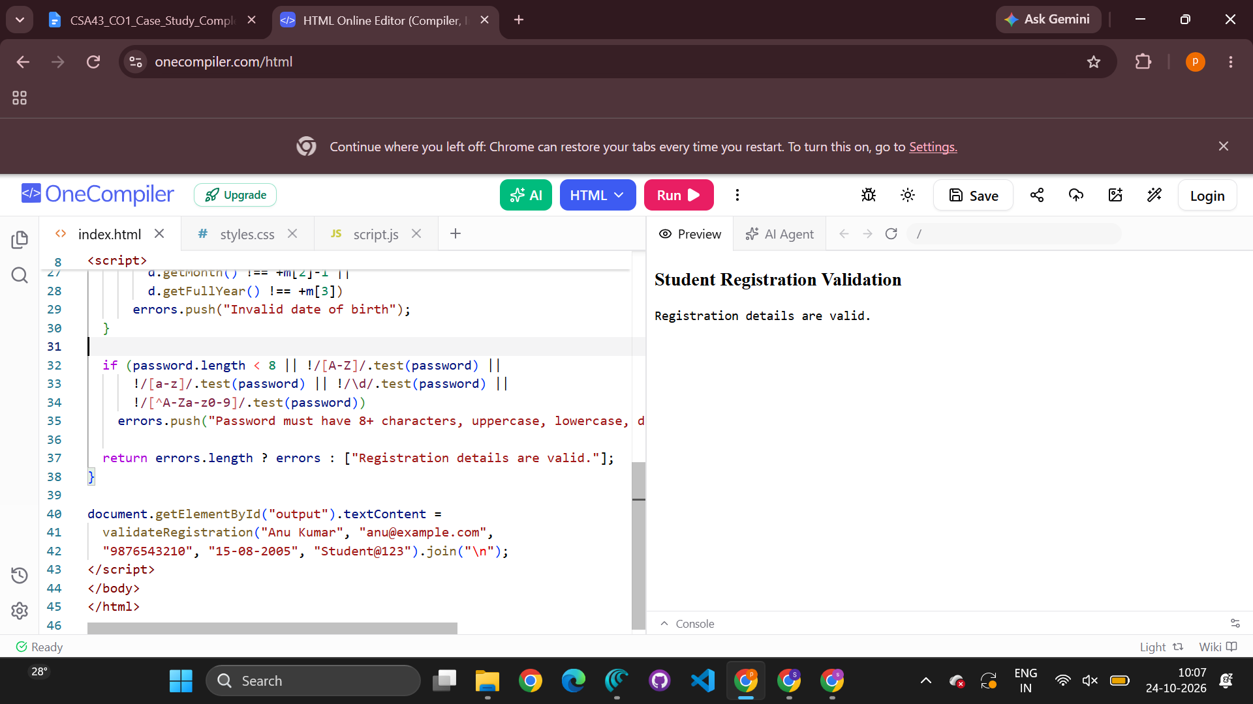

2. Password Strength Validation
The password must have at least 10 characters, two or more digits, uppercase and lowercase letters, a special character, and no whitespace. The program reports every failed condition.
JavaScript Program
function validatePassword(password) {
const errors = [];

if (password.length < 10) {
errors.push("Password must contain at least 10 characters.");
}
if ((password.match(/\d/g) || []).length < 2) {
errors.push("Password must contain at least two digits.");
}
if (!/[A-Z]/.test(password)) {
errors.push("Password must contain at least one uppercase letter.");
}
if (!/[a-z]/.test(password)) {
errors.push("Password must contain at least one lowercase letter.");
}
if (!/[^A-Za-z0-9\s]/.test(password)) {
errors.push("Password must contain at least one special character.");
}
if (/\s/.test(password)) {
errors.push("Password must not contain whitespace.");
}

return errors.length ? errors : ["Password is valid and strong."];
}

console.log(validatePassword("Strong@1234"));
console.log(validatePassword("weak pass"));
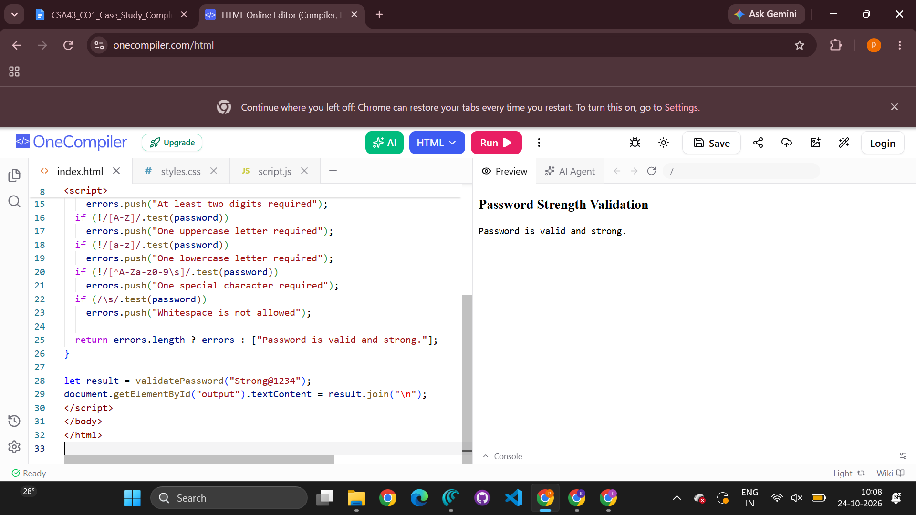

3. Email Address Validation
The program requires exactly one @ symbol, a non-empty username and domain, an extension of at least two letters, and rejects spaces and consecutive dots.
JavaScript Program
function validateEmail(email) {
if (/\s/.test(email) || email.includes("..")) return false;
if ((email.match(/@/g) || []).length !== 1) return false;

const parts = email.split("@");
const username = parts[0];
const domain = parts[1];

if (!username || !domain) return false;
if (username.startsWith(".") || username.endsWith(".")) return false;

return /^[A-Za-z0-9-]+(?:\.[A-Za-z0-9-]+)*\.[A-Za-z]{2,}$/.test(domain);
}

console.log(validateEmail("student@example.com")); // true
console.log(validateEmail("student..name@example.com")); // false
console.log(validateEmail("student@example.c")); // false
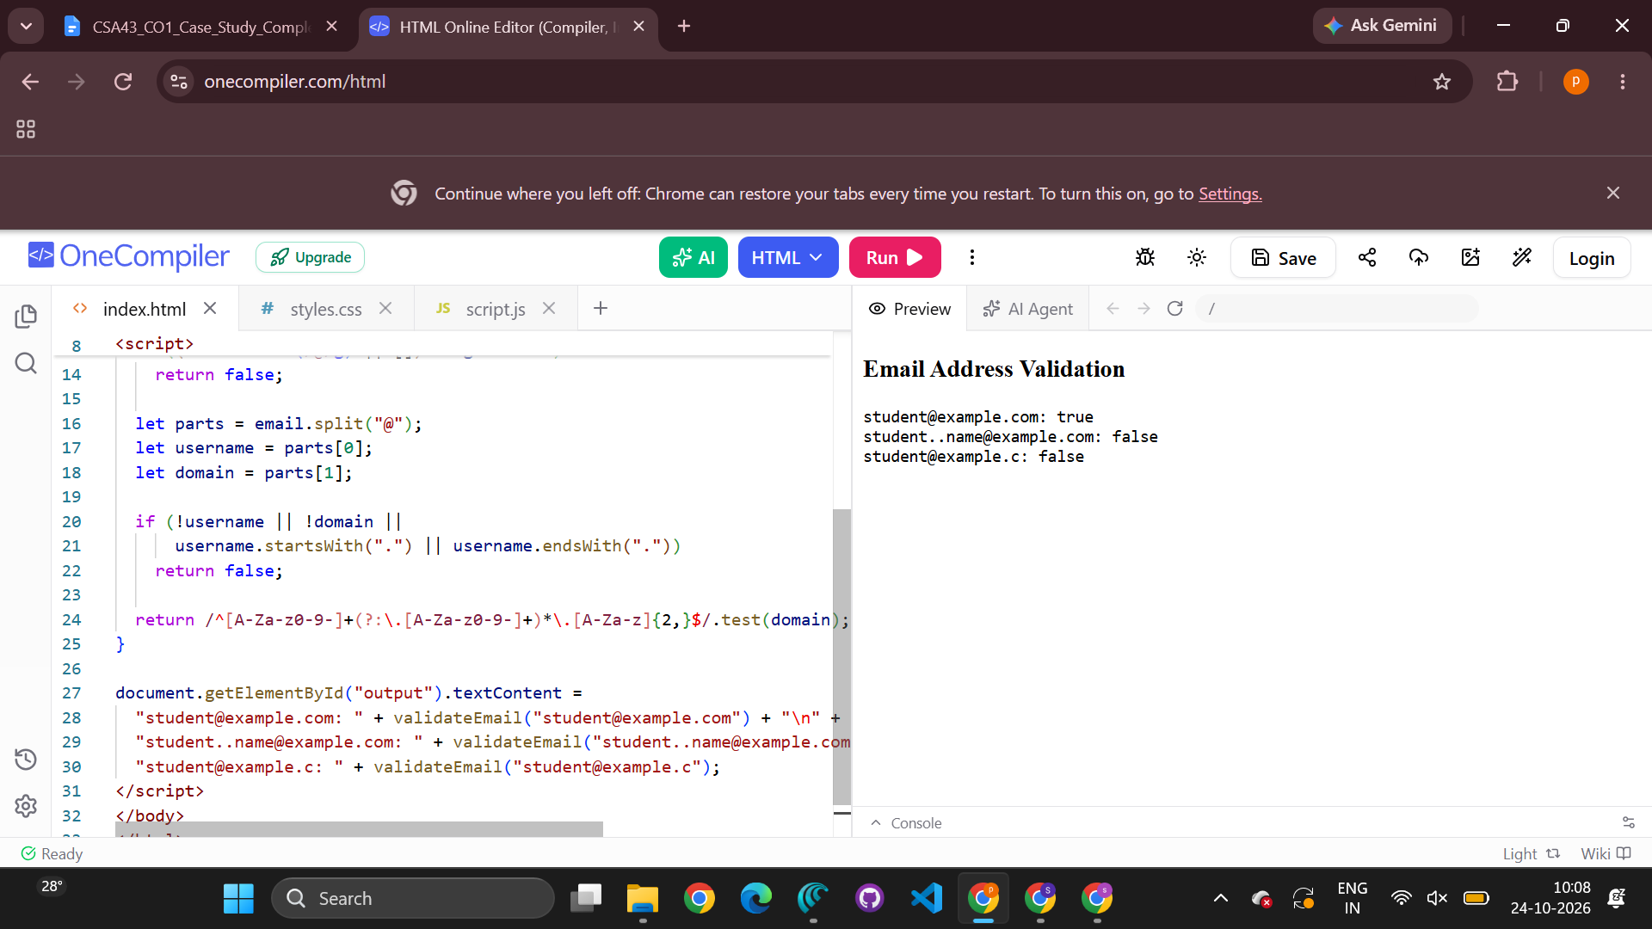

4. Username Validation

The username must start with a letter, contain only letters, digits, and underscores, be 6–15 characters long, not end with an underscore, and not contain consecutive underscores.
JavaScript Program
function validateUsername(username) {
const pattern = /^[A-Za-z](?=.{5,14}$)[A-Za-z0-9]*(?:_[A-Za-z0-9]+)*$/;
return pattern.test(username);
}

console.log(validateUsername("student1")); // true
console.log(validateUsername("user__01")); // false
console.log(validateUsername("1student")); // false
console.log(validateUsername("student_")); // false
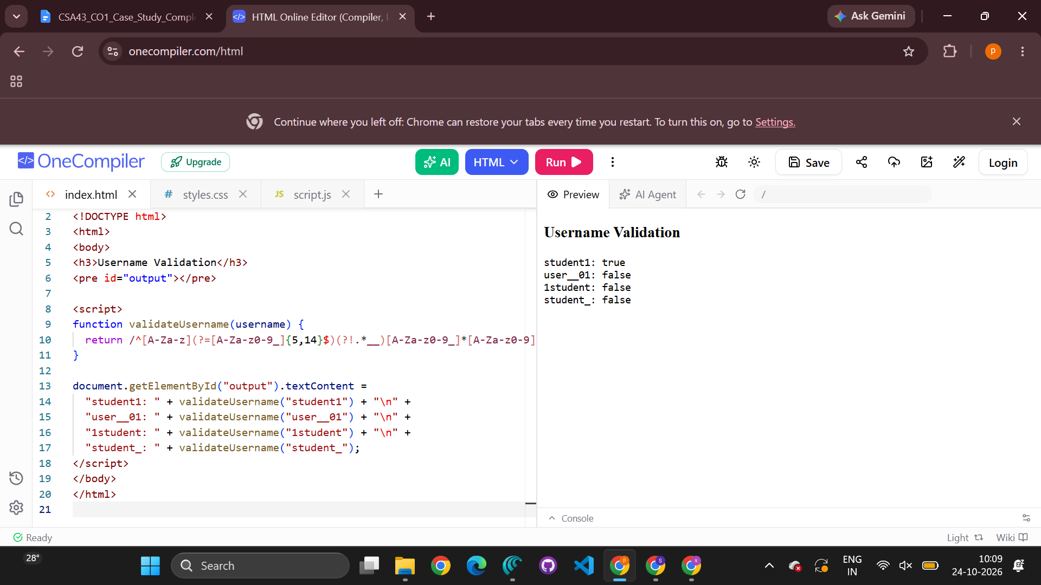

5. Extract and Analyse Data

The program uses regular expressions to extract mobile numbers, email addresses, and dates from a paragraph, then displays each category separately. The patterns are designed for common formats and may need adjustment for different country or date conventions.
JavaScript Program
const paragraph = `
Contact Anu at anu@example.com or call 9876543210.
The event is on 25-12-2026. For help, email support@site.org
or call 9123456780. Registration closes on 05/11/2026.
`;

const mobileNumbers = paragraph.match(/\b[6-9]\d{9}\b/g) || [];
const emailAddresses =
paragraph.match(/\b[A-Za-z0-9._%+-]+@[A-Za-z0-9.-]+\.[A-Za-z]{2,}\b/g) || [];
const dates = paragraph.match(/\b(?:\d{2}-\d{2}-\d{4}|\d{2}\/\d{2}\/\d{4})\b/g) || [];

console.log("Mobile numbers:", mobileNumbers);
console.log("Email addresses:", emailAddresses);
console.log("Dates:", dates);

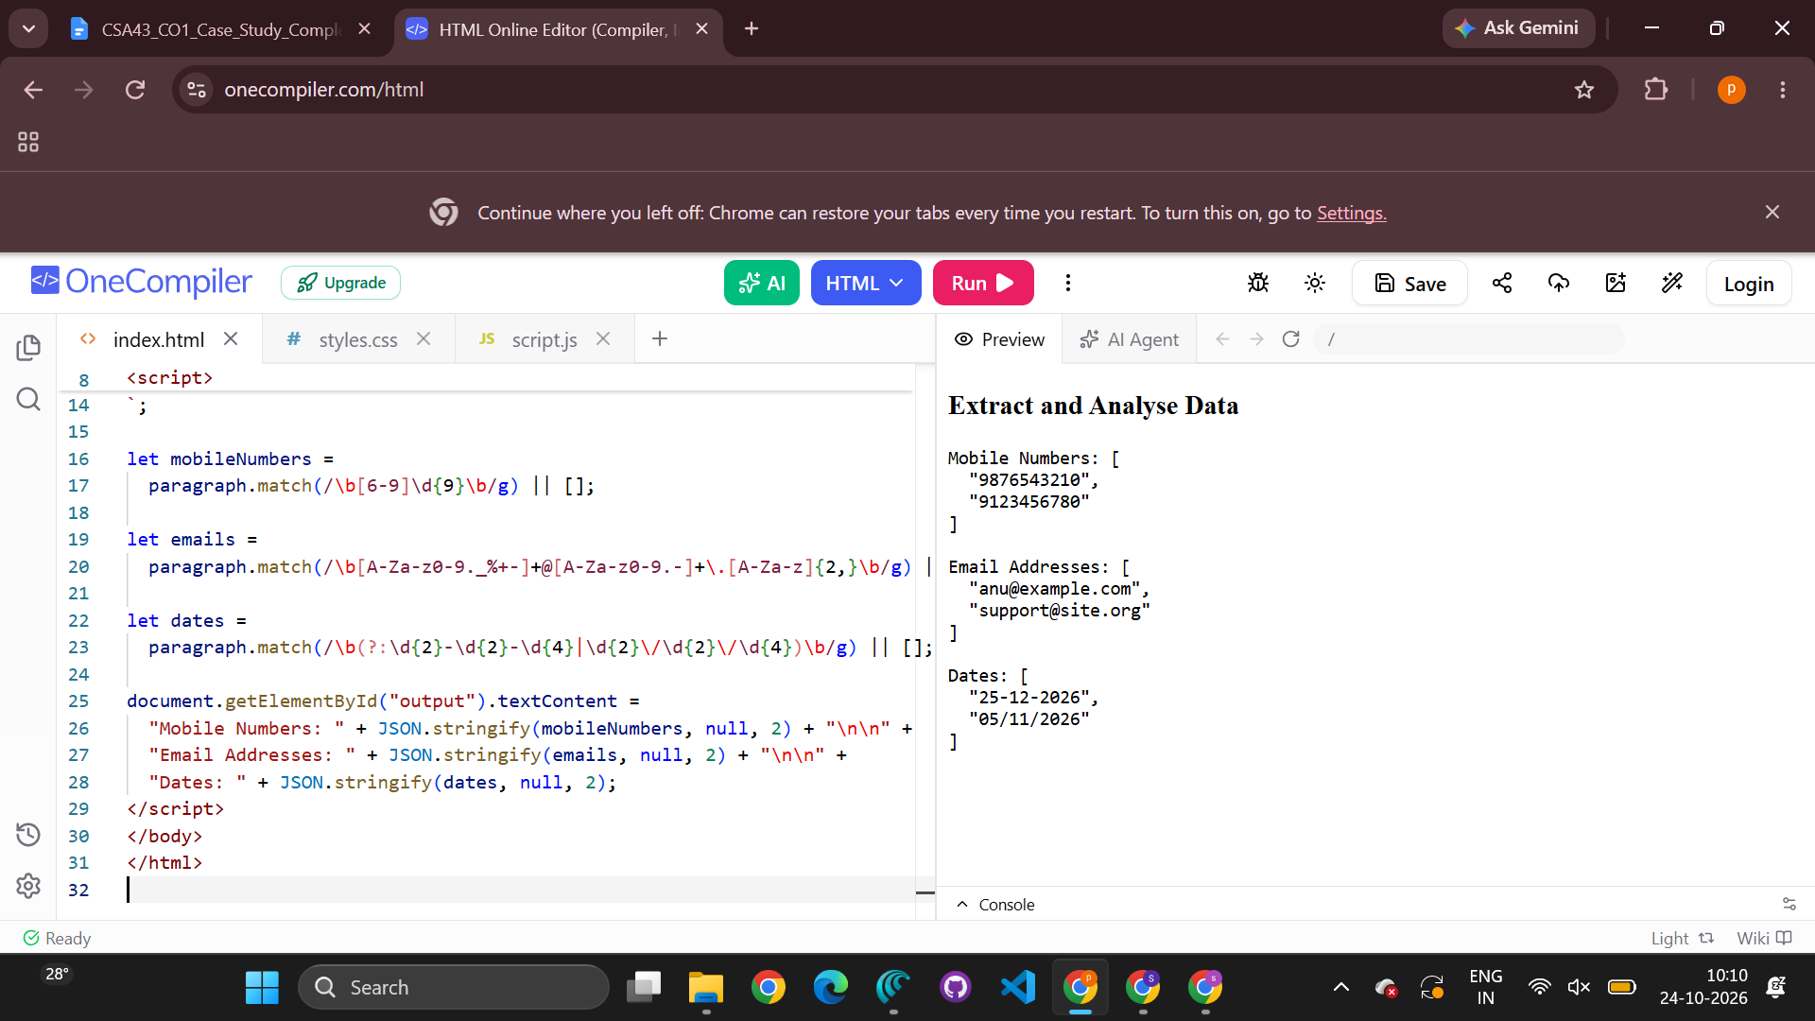

Conclusion
Regular expressions provide a concise way to validate input formats and extract matching data. These five programs apply pattern matching alongside additional checks where needed, such as confirming that a date exists on the calendar. Validation improves data quality, but important checks must also be repeated on the server in real applications.

